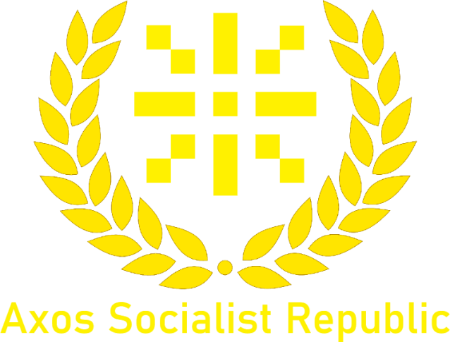

Hillside Agreement
On 13th of January 2025 _FroggyYosef came to Axford representing the 4 regions of Hillside, the most well-known being Phrogania. Throughout the meeting not much was said from the representative but the whole way through he agreed with what the Lord had to say. The following points are what was agreed:
- Hillside is a member of the ASR. The four regions will become provinces.
- The ASR’s legal system will be applied to the four regions. The local law system will overwrite the ASR one.
- All citizens of Hillside will become ASR members.
- Hillside will be administered by the ASR, and the ASR will have access to the land’s resources. However, Hillside will be able to use ASR resources and have bases on ASR land.
To be noted the Leader of Hillside has not agreed to the following terms but the representative has. Approval is pending from the leader but despite this the agreement has gone ahead. Hillside may retract approval of the agreement at any time except for War (including cold war).

